ECE3441-19134 – 2025FA
Lab #6: Hardware Implementation of a 4-Bit Calculator Using Full-Adder Chips
Anaya Scott - 1599670

Overview: Goals of the Lab
For this lab we continued to expand on the practical functionality of the 4- bit adder subtractor calculation. Taking the schematics from Lab 4 and using the same concept of Lab5 to build another 4- bit adder subtractor using a full adder and XOR chip. In question 1-3 showed the SimUAid schematics using the same numbers from Lab 4. Demonstrating the use of the 4- bit calculator.

Step-by-Step Procedures and Results
Question 1: the 4-bit full adder schematics.
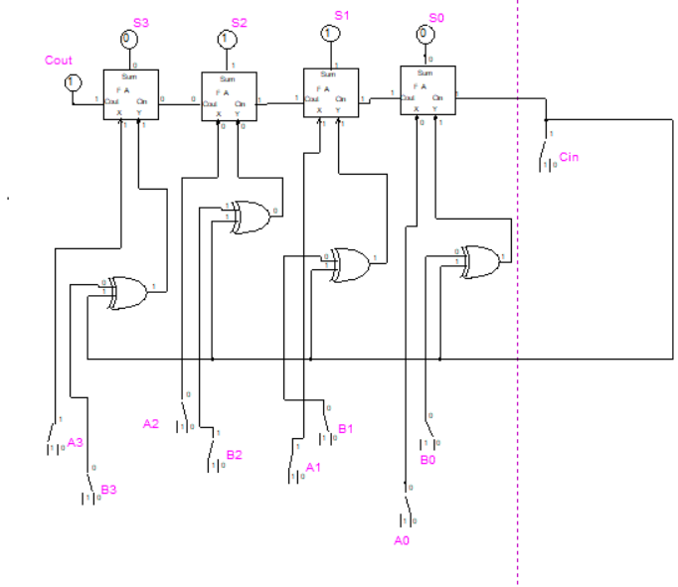
Question 2: Four Examples of A + B

A (dec) | B (dec) | A (bin) | B (bin) | Cin | Sum (dec) | Sum (bin)
+5 | +3 | 0101 | 0011 | 0 | +8 | 0000
+3 | -2 | 0011 | 1110 | 0 | +1 | 0001
-2 | +6 | 1110 | 0110 | 0 | +4 | 0100
-4 | -2 | 1100 | 1110 | 0 | -6 | 1010

- This is +5 + (+3) = +8 in binary, which will cause an overflow.
  - 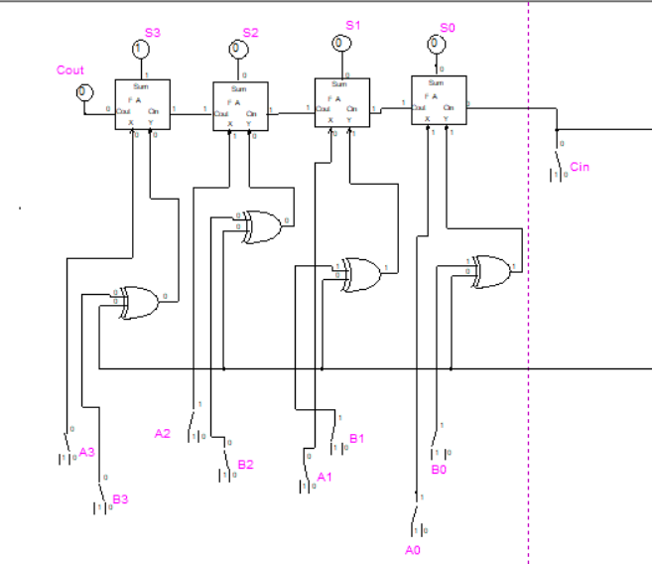
- This is +3 + (-2) = 1
  - 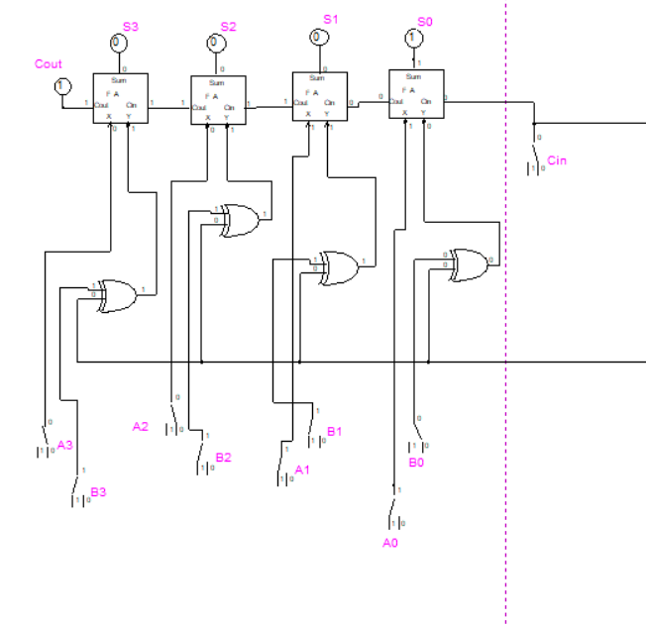
- This is -2 + (+6) = +4.
  - 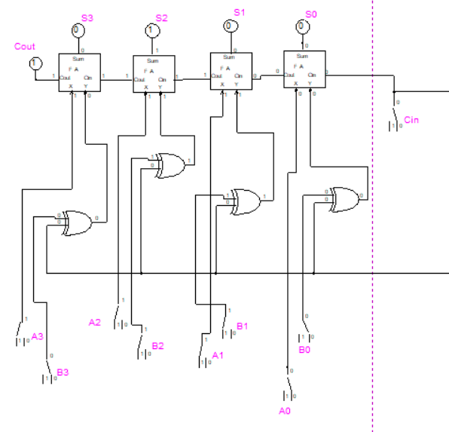
Figure 1: This is the photo for c.

- This is -4 + -2 = -6
  - 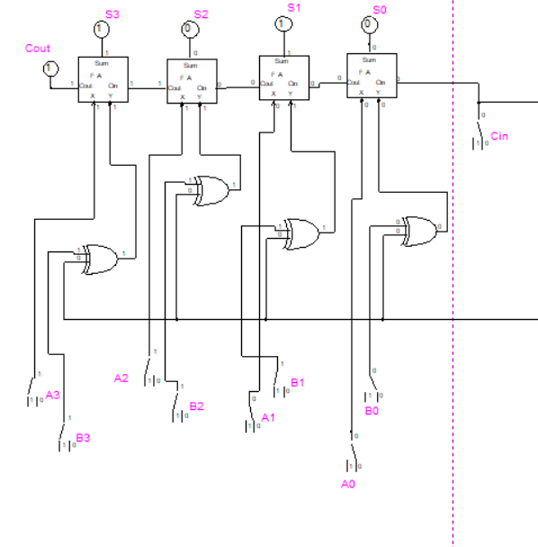
Question 3: Four Examples of A – B
A (dec) | B (dec) | A (bin) | B (bin) | Cin | Sum (dec) | Sum (bin)
+4 | +2 | 0100 | 0010 | 1 | +2 | 0010
+5 | -1 | 0101 | 1111 | 1 | +6 | 0110
-6 | +1 | 1010 | 0001 | 1 | -5 | 1011
-3 | -4 | 1101 | 1100 | 1 | -7 | 1001

- This is +4 - +2 = +2
  - 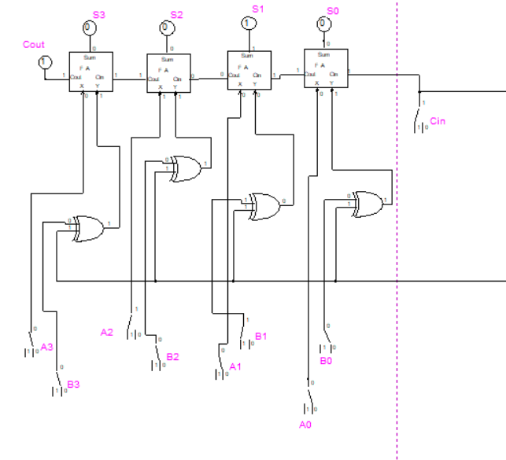
- This is +5 – (-1) = +6
  - 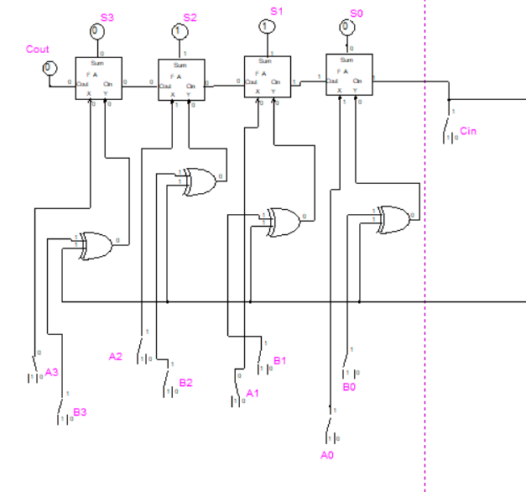
- This is -6 – (+1) = -5.
  - 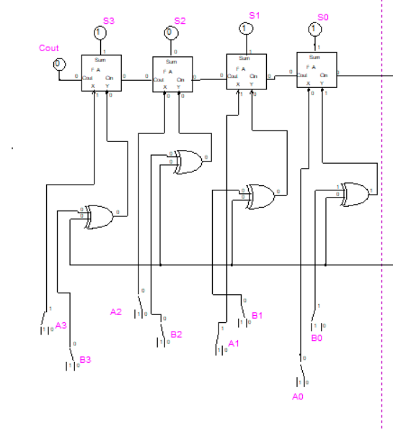
Figure 2: this figure is for c of question 3.
- This is -3 – (-4) = -7.
  - 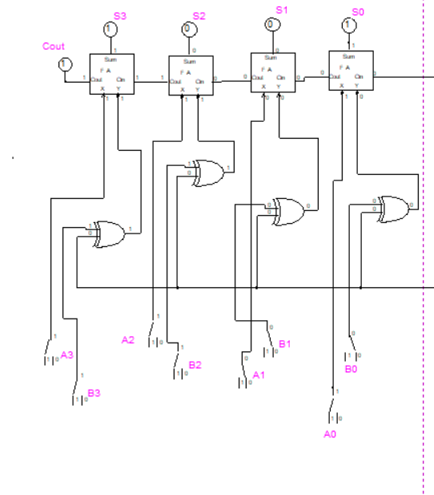

Part 2
Question 4. What pull-up or pull-down resistors are you using and why?
The pull-down resistors that were used in this lab were 470 ohms and 200 ohms resistors, as they help pull down and distribute power efficiently without damaging any chips or light.
Question 5. Demo was done in person.

Conclusion
In this lab, we learned how to read and understand the implementation of the full adder chip for a 4-bit calculator. Which provides another route to creating a 4-bit calculator compared to lab 5. With the hands-on experimentation, I gained a better understanding of the logical operation of the full adder chip. This experiment overall help reinforce the lectures and process from Lab 5 troubleshooting.

